**UECS3313/MPU33213**

**Computer Ethics and Professional Responsibility**

**Tutorial 8**

**Work**

1. Describe 4 positive and 4 negative impacts that computers and technology has had on jobs and employment.
2. Provide 5 reasons to support and 5 reasons to oppose the use of telecommuting.
3. Differentiate between the terms outsourcing and offshoring. What is the main advantage and disadvantage of offshoring in terms of the impact on the wealthier and developed countries that engage in it?
4. Give ethical arguments to support and oppose companies doing searches on social network media in order to obtain information about job applicants as part of the decision-making process in hiring new employees.
5. Describe in detail two main ways to help protect job applicants’ privacy and reduce the consequences when employers choose to do social media searches to screen prospective employees.
6. Describe 5 reasons for monitoring employees by the employer.
7. In many lawsuits involving disputes between the employee’s privacy rights and the employer’s right to monitor their activities, the legal decisions have generally tended to side with the company. Briefly discuss 3 exceptions to this general situation.
8. There is controversy over whether employers have the right to restrict social media conversations of their employees, as this can be argued to be violation of their freedom of speech rights. Provide four examples of conversations that you feel an employer can ethically restrict the employee from engaging in without significantly reducing their freedom to express themselves.
9. Give 4 reasons that a company might have to prohibit personal email accounts, social media, laptops, smartphones, and other devices for work purposes.
10. Some organizations have proposed a law to prohibit monitoring of customer-service or data entry employees with more than 10 years experience. Comment on whether this could be useful for the organization and justify your answer
11. Refer to the following screenshot. Do you think these "e-mail spies" are a good idea, or do you consider it a personal infringement? Have you been the victim of a malicious e-mailer at work? Discuss your views and/or experiences.

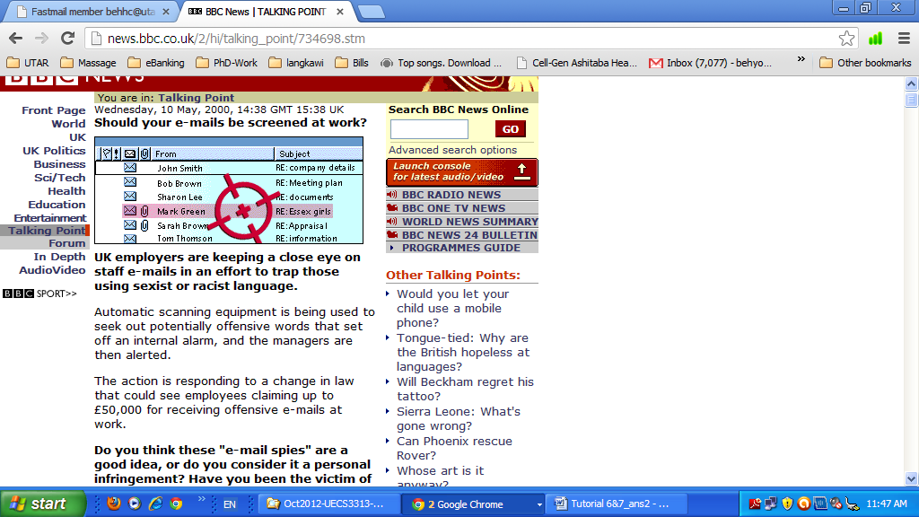

Source: <http://news.bbc.co.uk/2/hi/talking_point/734698.stm>